Internal Css

# Program 1:

<!DOCTYPE html>

<html lang="en">

<head>

    <meta charset="UTF-8">

    <meta name="viewport" content="width=device-width, initial-scale=1.0">

    <title>Document</title>

    <style>

        h1{

            color: white;

            background-color: blue;

        }

        p{

            color: green;

            background-color: antiquewhite;

        }

    </style>

</head>

<body>

    <h1>ANGULAR</h1>

    <p>Angular is a popular open-source web application framework maintained by Google and a community of developers. It is used for building dynamic, single-page web applications (SPAs). Angular provides a comprehensive set of features for creating interactive and responsive web applications, including data binding, dependency injection, and routing.</p>

    <h1>FLUTTER </h1>

    <p>Flutter is an open-source UI software development kit created by Google. It is used to develop applications for Android, iOS, Linux, Mac, Windows, Google Fuchsia, and the web from a single codebase. Flutter uses the Dart programming language and provides a rich set of pre-built widgets that make it easy to create beautiful and highly responsive user interfaces. One of the key features of Flutter is its hot reload capability, which allows developers to quickly see the effects of code changes without having to restart the app. </p>

    <h1>ANDROID</h1>

    <P>Android is a mobile operating system developed by Google, based on the Linux kernel and designed primarily for touchscreen devices such as smartphones and tablets. It is the most widely used mobile operating system globally, powering millions of devices from various manufacturers. Android provides a rich set of features and a customizable user interface, allowing users to personalize their devices to suit their preferences.</P>

</body>

</html>

# Output

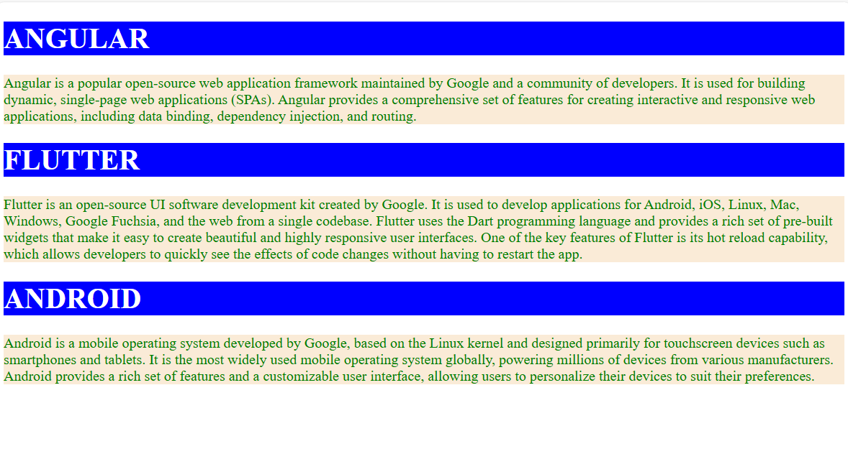

# Program 2

<!DOCTYPE html>

<html lang="en">

<head>

    <meta charset="UTF-8">

    <meta name="viewport" content="width=device-width, initial-scale=1.0">

    <title>Document</title>

    <style>

        img{

            width: 200px;

            height: 200px;

            float: left;

            border: 5px solid;

            border-radius: 10px;

            margin: 20px;

            padding: 40px;

        }

    </style>

</head>

<body>

    <img src="../FrameSet/imgs/camera.jfif" alt="">

    <img src="../FrameSet/imgs/dvd.jpg" alt="">

    <img src="../FrameSet/imgs/laptop.jfif" alt="">

    <img src="../FrameSet/imgs/mobile.jfif" alt="">

    <img src="../FrameSet/imgs/tv.jfif" alt="">

    <img src="../FrameSet/imgs/see.jfif" alt="">

</body>

</html>

# Output

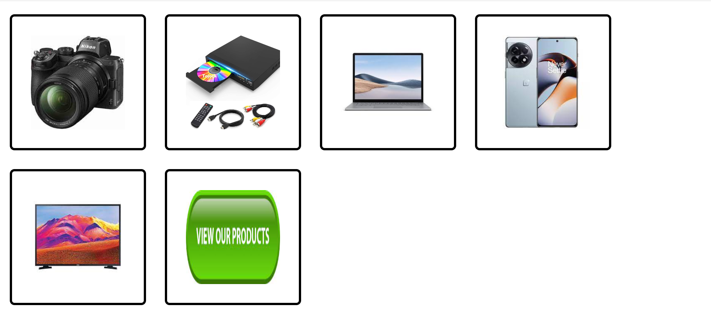

# Program 3

<!DOCTYPE html>

<html lang="en">

<head>

    <meta charset="UTF-8">

    <meta name="viewport" content="width=device-width, initial-scale=1.0">

    <title>Document</title>

    <style>

        div{

            width: 550px;

            height: 280px;

            border: 2px solid;

            border-radius: 6px;

            background-color: aquamarine;

            box-shadow: 10px 20px 50px rgb(171, 170, 170);

        }

        img{

            height: 250px;

            width: 250px;

            float: left;

        }

        p{

            width: 250px;

            float: left;

        }

    </style>

</head>

<body>

    <div>

        <img src="../FrameSet/imgs/ang.png" alt="">

        <p>Angular is a popular open-source web application framework maintained by Google and a community of developers.

            Angular is a popular open-source web application framework maintained by Google and a community of developers.

            Angular is a popular open-source web application framework maintained by Google and a community of developers.

            Angular is a popular open-source web application framework maintained by Google and a community of developers.

        </p>

    </div>

</body>

</html>

# OutPut :

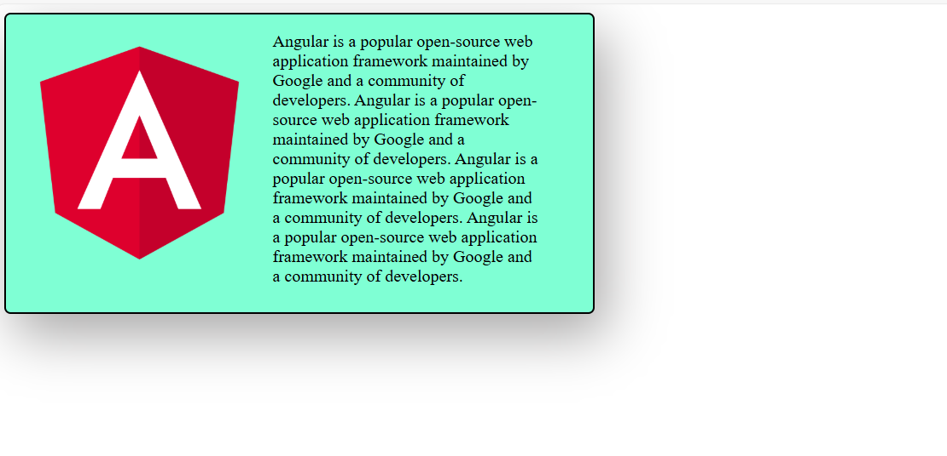

# Program 4 :

<!DOCTYPE html>

<html lang="en">

<head>

    <meta charset="UTF-8">

    <meta name="viewport" content="width=device-width, initial-scale=1.0">

    <title>Document</title>

    <style>

        div{

            width: 280px;

            height: 400px;

            border: 3px solid #3670f9;

            border-radius: 20px;

            text-align: center;

            background-image: linear-gradient(45deg,red,orange,yellow);

        }

        img{

            border-radius: 50%;

            width: 100px;

            margin: 15px;

        }

        hr{

            width: 200px;

            height: 5px;

            background-color: white;

        }

    </style>

</head>

<body>

    <div>

        <img src="../FrameSet/imgs/back.webp" alt="">

        <hr>

        <h4>ARUN K MENON</h4>

        <h4>Btech</h4>

        <h4>NIT KOZHIKODE</h4>

        <H4>22</H4>

    </div>

</body>

</html>

# OutPut :

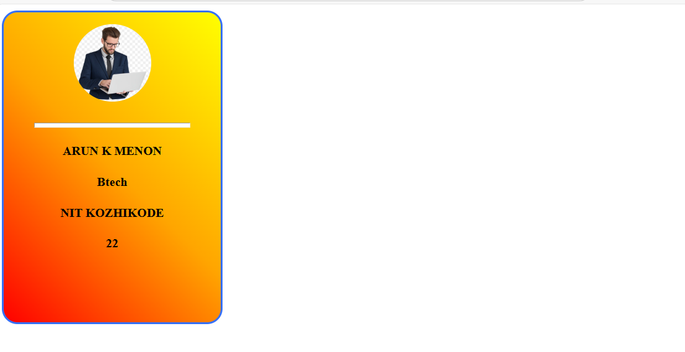

# Program 5 :

<!DOCTYPE html>

<html lang="en">

<head>

    <meta charset="UTF-8">

    <meta name="viewport" content="width=device-width, initial-scale=1.0">

    <title>Document</title>

    <style>

        table{

            width: 500px;

            height: 500px;

            border-collapse: collapse;

            text-align: center;

            border-color: black;

        }

        thead{

            background-color: #3670f9;

            color: white;

        }

        tbody{

            background-color: greenyellow;

        }

    </style>

</head>

<body>

    <table border="5px">

        <thead>

            <tr>

                <td>Name</td>

                <td>Post</td>

                <td>Salary</td>

                <td>Joining Date</td>

            </tr>

        </thead>

        <tbody>

            <tr>

                <td>Employee1</td>

                <td>Manager</td>

                <td>45000</td>

                <td>24/03/2025</td>

            </tr>

            <tr>

                <td>Employee2</td>

                <td>Developer</td>

                <td>21000</td>

                <td>24/4/2025</td>

            </tr>

            <tr>

                <td>Employee3</td>

                <td>Tester</td>

                <td>25000</td>

                <td>14/03/2025</td>

            </tr>

            <tr>

                <td>Employee4</td>

                <td>Software Developer</td>

                <td>26000</td>

                <td>14/03/2025</td>

            </tr>

        </tbody>

    </table>

</body>

</html>

# OutPut :

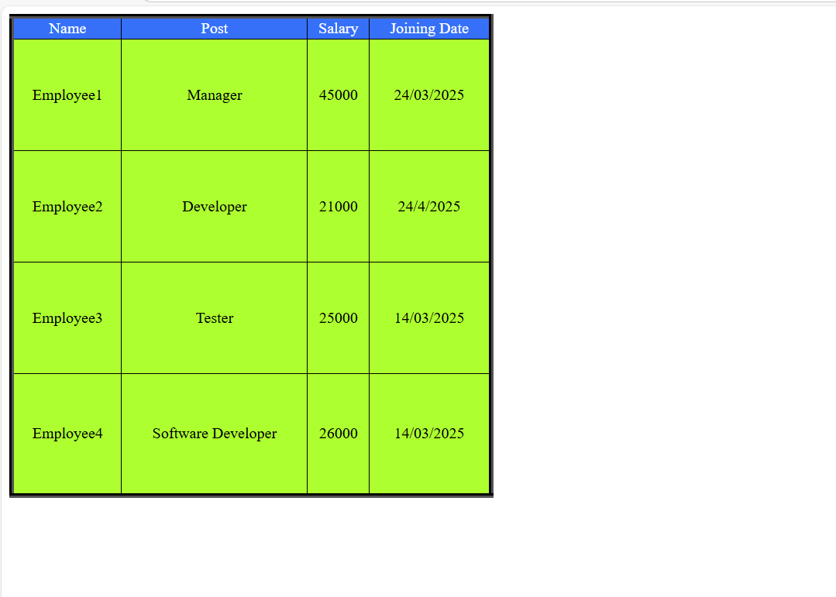

# Program 6 :

<!DOCTYPE html>

<html lang="en">

  <head>

    <meta charset="UTF-8" />

    <meta name="viewport" content="width=device-width, initial-scale=1.0" />

    <title>Document</title>

    <style>

      body {

        width: 100%;

        height: 100vh;

        display: block;

        margin-left: auto;

        margin-right: auto;

      }

      .card {

        width: 350px;

        height: 450px;

        margin: 200px;

        border: none;

        border-radius: 10px;

        position: relative;

        text-align: center;

        box-shadow: 2px 10px 20px rgb(62, 61, 61);

      }

      .sub {

        width: inherit;

        height: 150px;

        background-color: rgb(128, 0, 255);

        border-top-left-radius: 10px;

        border-top-right-radius: 10px;

      }

      img {

        width: 100px;

        height: 100px;

        border: 5px solid white;

        border-radius: 50%;

        position: absolute;

        top: 95px;

        left: 120px;

      }

      .title {

        margin-top: 60px;

      }

      .subtitle {

        color: purple;

      }

      p {

        margin: 20px;

      }

      button {

        width: 110px;

        height: 30px;

        color: white;

        background-color: rgb(128, 0, 255);

        border: none;

        border-radius: 20px;

      }

    </style>

  </head>

  <body>

    <div class="card">

      <div class="sub"></div>

      <img src="../images/avatar.jpg" alt="" />

      <h2 class="title">Alaina Wick</h2>

      <h2 class="subtitle">Front-end Developer</h2>

      <p>

        Lorem ipsum dolor sit amet consectetur adipisicing elit. Eaque porro

        ratione, fugiat adipisci cupiditate quis soluta voluptate ,

      </p>

      <button>view Profile</button>

    </div>

  </body>

</html>

# OutPut :

